|  |  |  |  |  |  |
| --- | --- | --- | --- | --- | --- |
|  |  |  |  |  | logo1.png |

|  |  |  |  |
| --- | --- | --- | --- |
| Course Name | | Graphic design(canva) | |
| College Name | | Mangayarkarasi College of Arts and Science for Women Paravai, Madurai - 625002 | |
| College Code | | MKU251 | |
| Skill Offering Id | | FEB67F49F27BE2CB38A4E229BD4CE940 | |
| Project Title | | Personalized invitation using canva | |
| Project Submitted To | | Madurai Kamaraj University ( Naan Mudhalvan Scheme(TNSDC)) | |
| Year | | 2023 | |
| Department | | B.A English | |
| Semester | | 5 | |
| Group Number | | 7 | |
| Total Members of the Group | | 4 | |
| Group Members Details | | | |
| Name of the Member | University Register. No | | Student NM ID |
| 1. JEEVA DHARSHINI.N | C1A17423 | | FEB67F49F27BE2CB38A4E229BD4CE940 |
| 1. MALAYARASI S | C1A17431 | | FFE37A08A89515280EB4D4BBD85D0BCF |
| 1. NEENA O | C1A17435 | | 9D434A6D242FDC79220497F81CA4FB59 |
| 1. NEHA.B | C1A17436 | | D6EB9BDAAA94E98A7C04EE7B7D34E7E0 |
|  |  | |  |
| Under the Guidance | | DR. MEENA | |
| SPOC | | Ms.P.UMADEVI | |

**PERSONALIZED INVITATION USING CANVA**

1. **Introduction.**

***1.1 Overview***

**Canva offers a wide collection of printable invitation templates you can use and personalize to suit any event. Planning a wedding? There are invitations from Engagement Parties to Save the Dates to Rehearsal Dinners, and, of course, invites to the Wedding Day itself. Canva has its design platform that you can use to make your party invitation ideas come to life. Just drag and drop your favorite design elements, adjust the colors to fit your party motif, and don't forget to edit the text to make sure all the right details are there.**

***1.2 Purpose***

**Canva has everything you need to create a wedding invitation to remember. Personalize professionally-designed templates to suit your vision for your big day then order high-quality prints of your unique design. We'll even deliver them right to your doorstep for free. As the name suggests, digital wedding invitations are simply wedding invitations sent virtually to your guests via email. Your loved ones will receive a copy of your invitation straight to their inbox.**

1. **Problem Definition and Design Thinking**
   1. Empathy Map

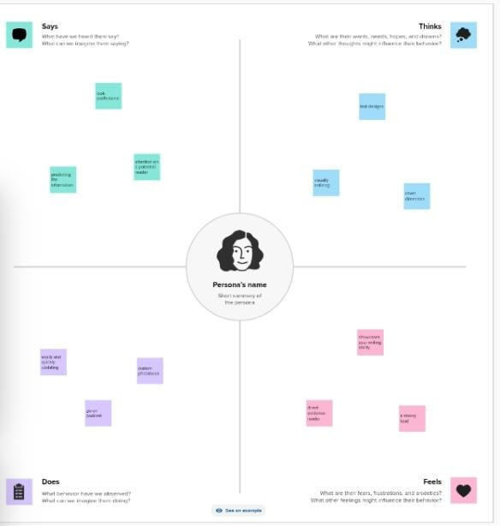

**2.2 Ideation and Brainstroming Map**

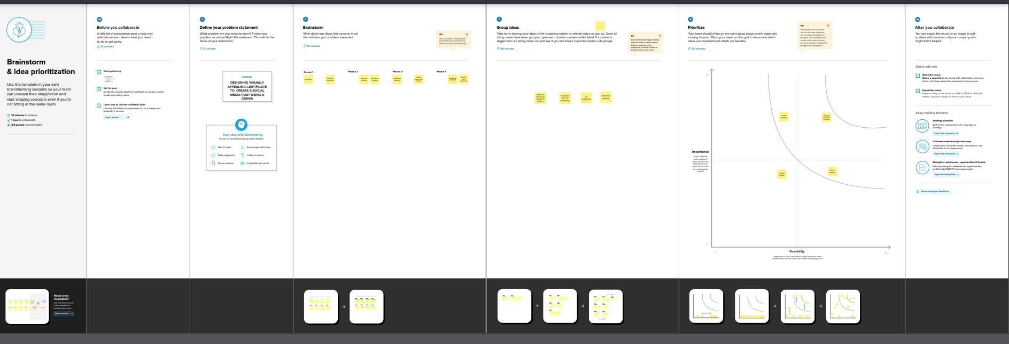

1. **Result:**

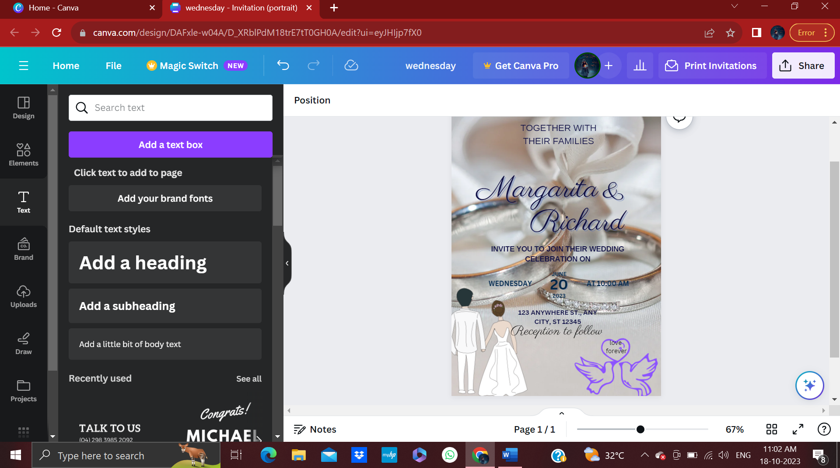

**MILESTONE:1 1:** 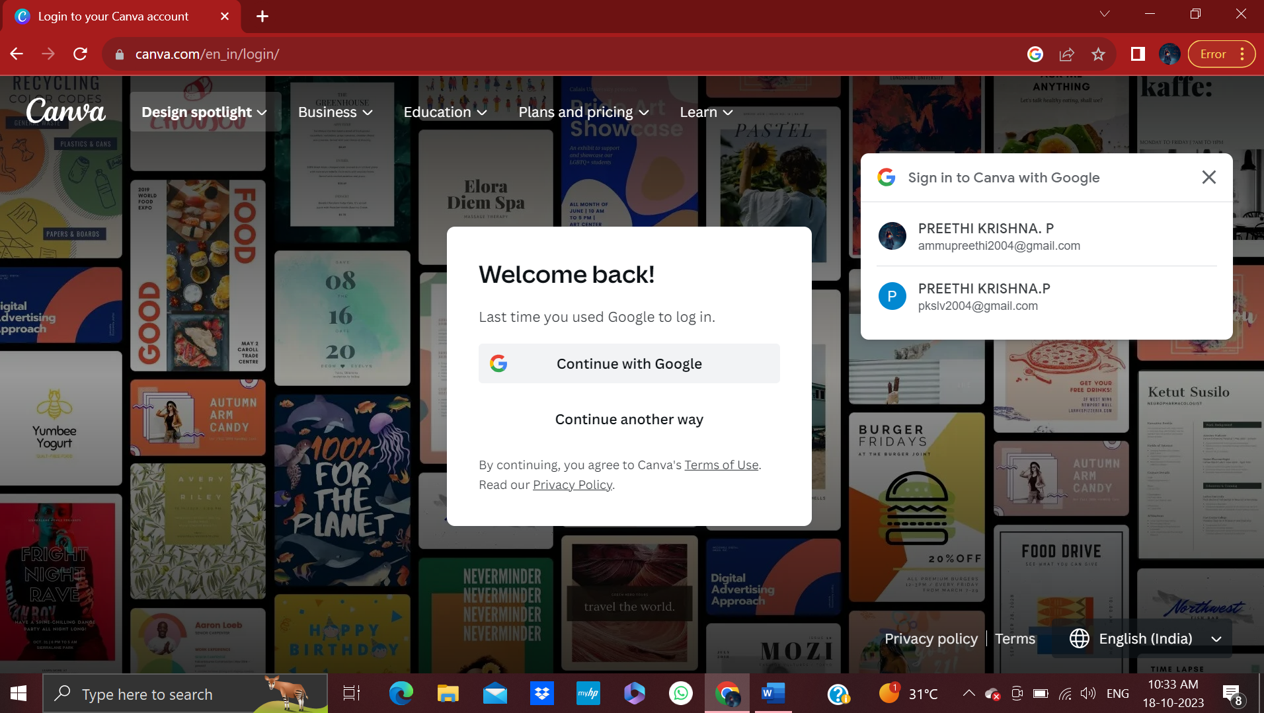

**MILESTONE:2**

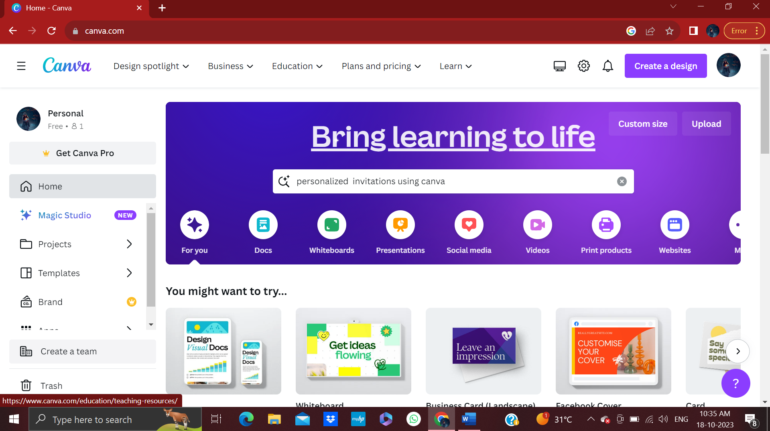

**MILESTONE:3**

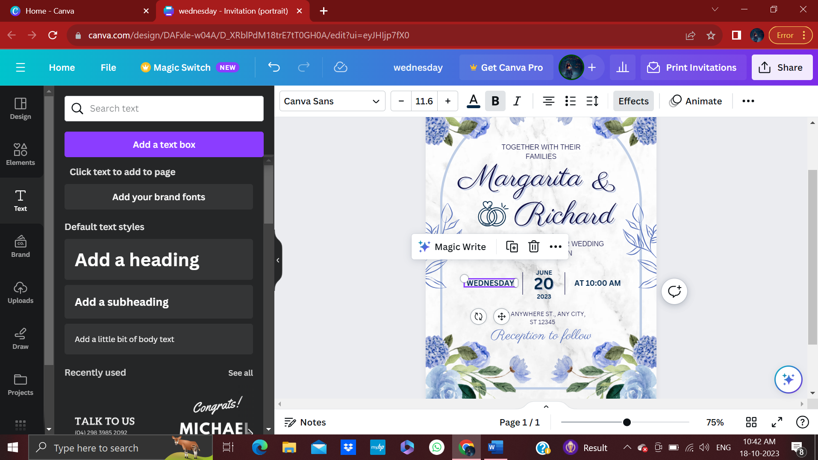

**MILESTONE:4**

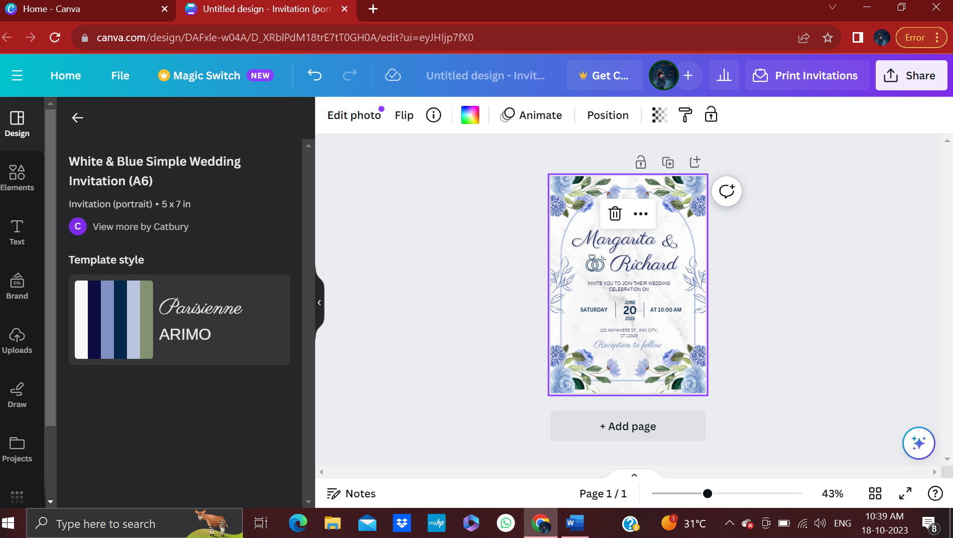

**MILESTONE:5**

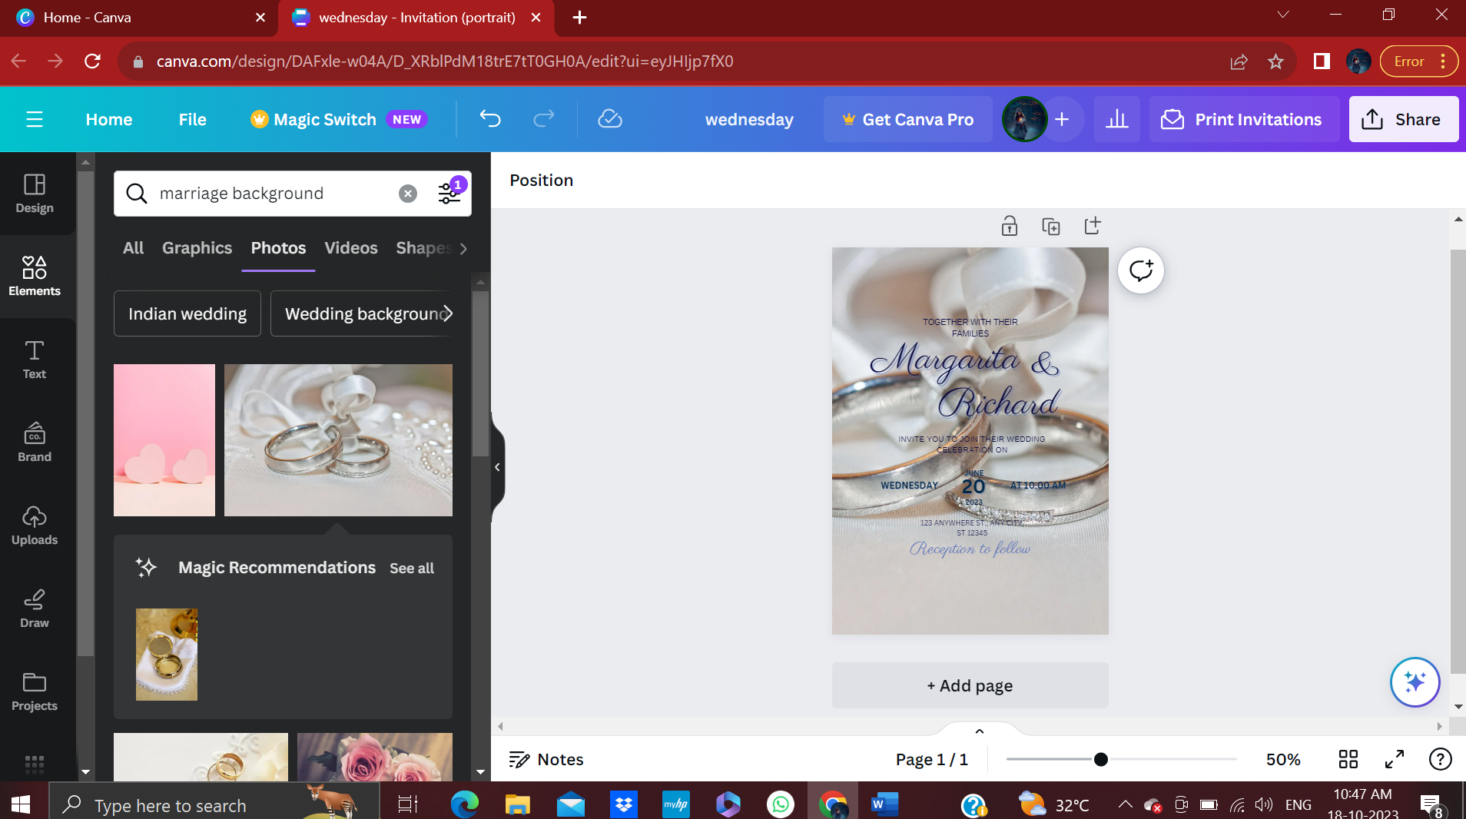

**MILESTONE:6**

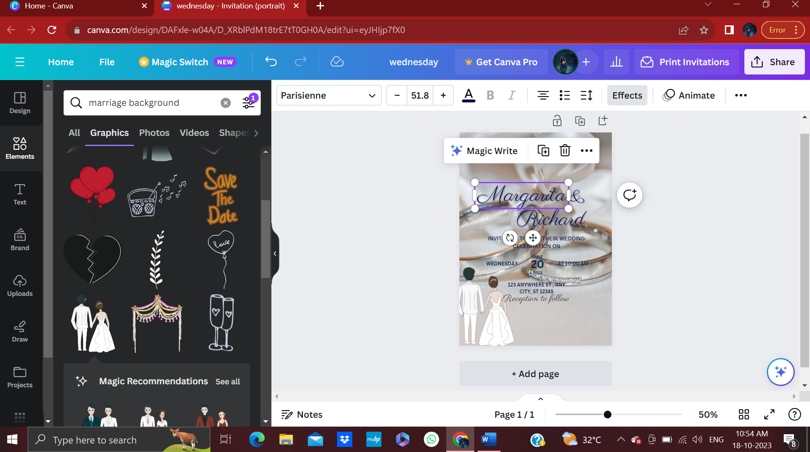

**MILESTONE:7**

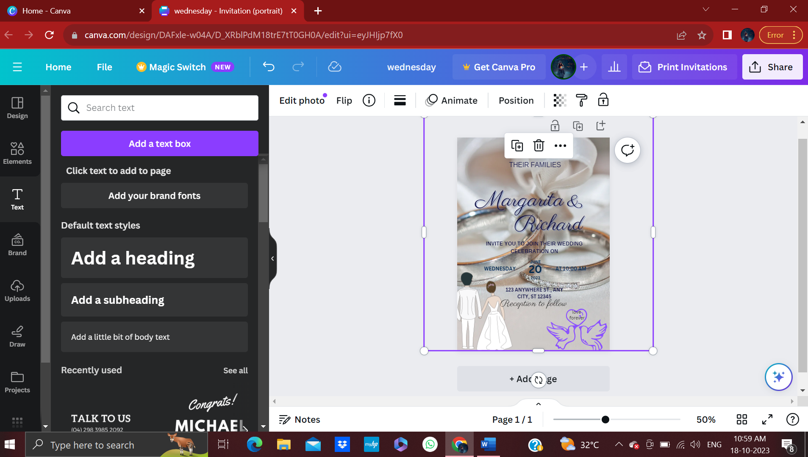

**MILESTONE:8**



***4. Advantages :***

* + - * **Open Canva. Launch Canva and search for "Invitation."**
      * **Look for the best template. Narrow down your search by specifying the specific occasion the invite is for. ...**
      * **Add images and text. Use the drag-and-drop tool to select image, illustration, or other elements and move them to your design.**
      * **Customize a bit more.**
      * **Print or share.**

***Disadvantages:***

Although Canva offers great features and a user-friendly interface, it also have a few drawbacks that you should know. Canva does not have local file storage. This means if the website is down for some reason, you will need to wait to access your designs to make new changes. Overuse of Designs.

1. **Conclusion:**

An invitation card conveys the overall tone of the event they are invited to. Moreover, when you receive a card for a birthday party or wedding, the event automatically stands out from the rest of the invitations you have received, making it more important than the rest.

1. **Future scope:**

Canva has everything you need to create a wedding invitation to remember. Personalize professionally-designed templates to suit your vision for your big day then order high-quality prints of your unique design. We'll even deliver them right to your doorstep for free.Makes your guests feel special- Obviously, your event is a “special occasion.” Sending a customized paper invitation shows that you put in the effort and even spent money to make sure you included them in your event. It also shows how much planning you have put into your event.